Java Scripts:
- For auto populated html code in .html file we use “shift + !”. It will create boilerplate code.
- Win+k for clear the browser console after opening the inspect.

Variable: Variables are container for data.
In JavaScript, variable names must follow these rules:
- A variable name must begin with a letter, underscore (_), or dollar sign ($).
  - It cannot begin with a number.
- After the first character, numbers can be used.
- Spaces are not allowed in variable names.
- Special characters are generally not allowed, except _ and $.
- Variable names are case-sensitive.
  - name, Name, and NAME are considered different variables.
- JavaScript reserved keywords cannot be used as variable names.
  - Examples: let, const, var, class, function, return, if, etc.
- Variable names should be meaningful and descriptive so the code is easy to understand.
- JavaScript commonly uses camelCase for variable names.
  - Example: firstName, totalAmount, userAge

let, const & var
var: Variable can be re-declared & updated. A global scope variable.
let: Variable cannot be re-declared but can be updated. A block scope variable.
const: Variable cannot be re-declared or updated. A block scope variable. Const should be a initial value before using it otherwise compiler will return one error.

Data Type in JS:
Primitive datatype
String | let name = "Ajeet";
Number | let age = 39;
BigInt | let num = 12345678901234567890n;
Boolean | let isLoggedIn = true;
Undefined | let x;
Null | let value = null;
Symbol | let id = Symbol("id");

BigInt in JavaScript
BigInt is used when you need to work with very large whole numbers that are bigger than JavaScript’s safe Number limit.
let bigNumber = 12345678901234567890n;
console.log(bigNumber);
2. Non-Primitive Data Types
Non-primitive types are reference types and can contain multiple values or more complex structures.
Main types:
- Object
- Array
- Function

Operators:

Arithmetic operators:
Operator | Meaning | Example
+ | Addition | 10 + 5 → 15
- | Subtraction | 10 - 5 → 5
* | Multiplication | 10 * 5 → 50
/ | Division | 10 / 5 → 2
% | Remainder | 10 % 3 → 1
** | Power | 2 ** 3 → 8
++ | Increment | x++
-- | Decrement | x--
Assignment operators:
Operator | Example | Same as
= | x = 10 | x = 10
+= | x += 5 | x = x + 5
-= | x -= 5 | x = x - 5
*= | x *= 5 | x = x * 5
/= | x /= 5 | x = x / 5
%= | x %= 5 | x = x % 5
**= | x **= 2 | x = x ** 2

Comparison Operators in JavaScript
Comparison operators are used to compare two values. The result is always true or false.
Operator | Meaning | Example | Result
== | Equal value | 5 == "5" | true
=== | Equal value & type | 5 === "5" | false
!= | Not equal value | 5 != "6" | true
!== | Not equal value or type | 5 !== "5" | true
> | Greater than | 10 > 5 | true
< | Less than | 10 < 5 | false
>= | Greater than or equal | 10 >= 10 | true
<= | Less than or equal | 5 <= 10 | true

Logical Operators in JavaScript
Logical operators are used to combine or reverse conditions. They return true or false.
Operator | Name | Example | Result
&& | AND | true && true | true
` | ` | OR
! | NOT | !true | false

Conditional statement:
if → One condition
if...else → Two possibilities
if...else if → Multiple conditions
nested if → Condition inside condition
switch → Multiple fixed values
ternary ? : → Short if...else
Reading Documentations: https://developer.mozilla.org/en-US/
Alert and prompt:
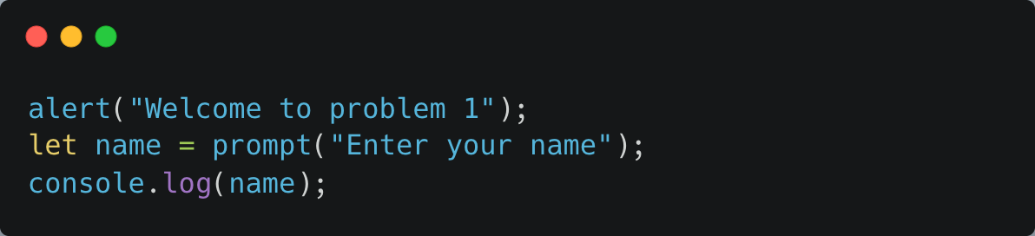
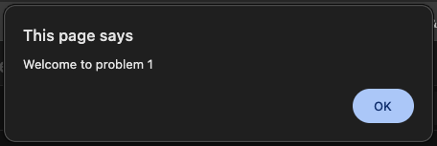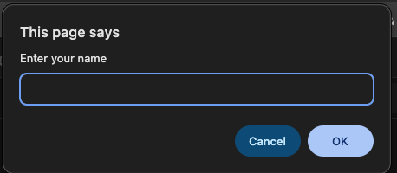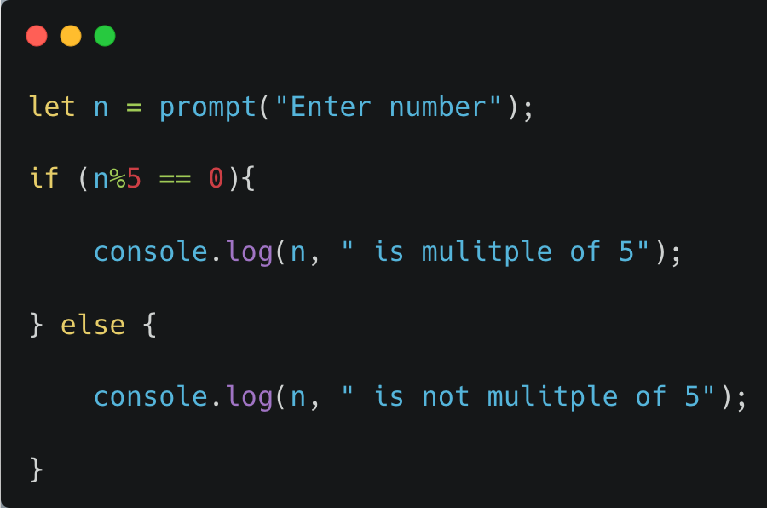

Strings in JavaScript
A String is a data type used to store text/characters.
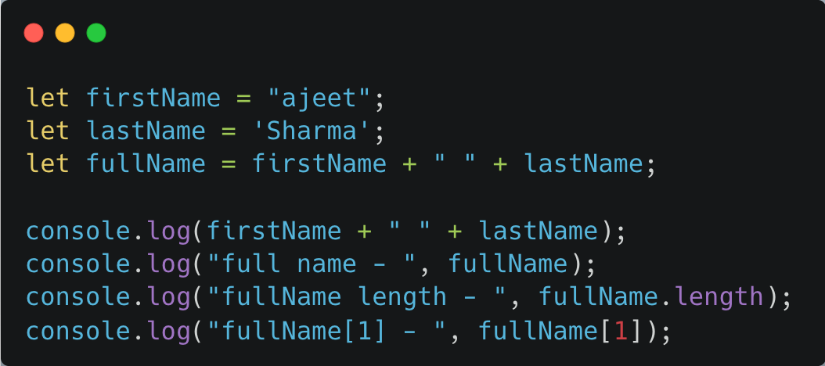

3. Template Literals ⭐
Instead of using multiple + operators:

We can use backticks (``).
String Interpolation in JavaScript
String interpolation means p utting variables or expressions directly inside a string.
In JavaScript, we use template literals with backticks ` and ${}.
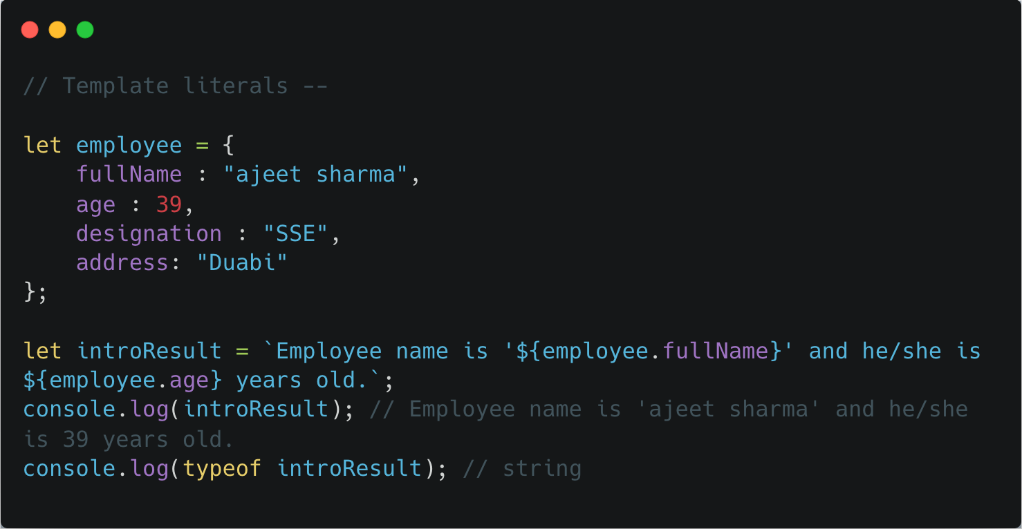
String interpolation = inserting variables or expressions inside a string using ${} with backticks.
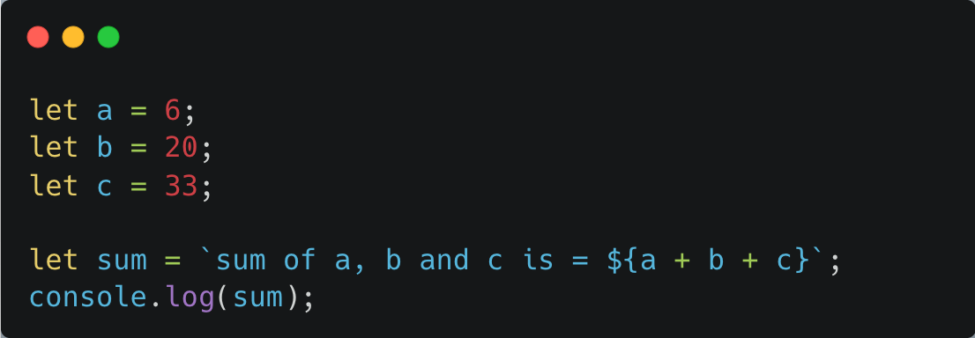

Escape Characters in JavaScript
Escape characters are special characters written with a backslash \ inside a string.
They are used when you want to include special characters or formatting that would otherwise be difficult to write.
Escape | Meaning | Example
\n | New line | "Hello\nWorld"
\t | Tab | "Hello\tWorld"
\' | Single quote | 'It\'s good'
\" | Double quote | "He said \"Hi\""
\\ | Backslash | "C:\\Users"
\b | Backspace | "Hello\b"
\r | Carriage return | "Hello\rWorld"

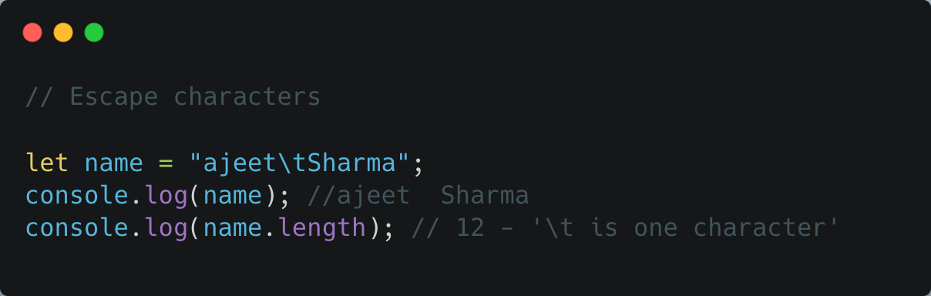
Method | Purpose | Example
.length | Get string length | text.length
.toUpperCase() | Convert to uppercase | text.toUpperCase()
.toLowerCase() | Convert to lowercase | text.toLowerCase()
.trim() | Remove spaces | text.trim()
.includes() | Check if text exists | text.includes("Java")
.startsWith() | Check starting text | text.startsWith("Hello")
.endsWith() | Check ending text | text.endsWith("Script")
.indexOf() | Find position | text.indexOf("Java")
.charAt() | Get character | text.charAt(0)
.slice() | Extract part | text.slice(0, 5)
.substring() | Extract part | text.substring(0, 5)
.replace() | Replace text | text.replace("JavaScript", "React")
.replaceAll() | Replace all occurrences | text.replaceAll("a", "A")
.split() | Convert string to array | text.split(" ")
.concat() | Join strings | text.concat(" Course")

String is Immutable in JavaScript
Immutable means: once a string is created, its original value cannot be changed.
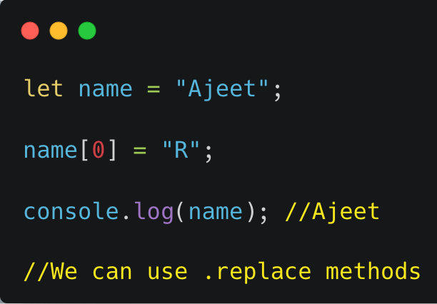
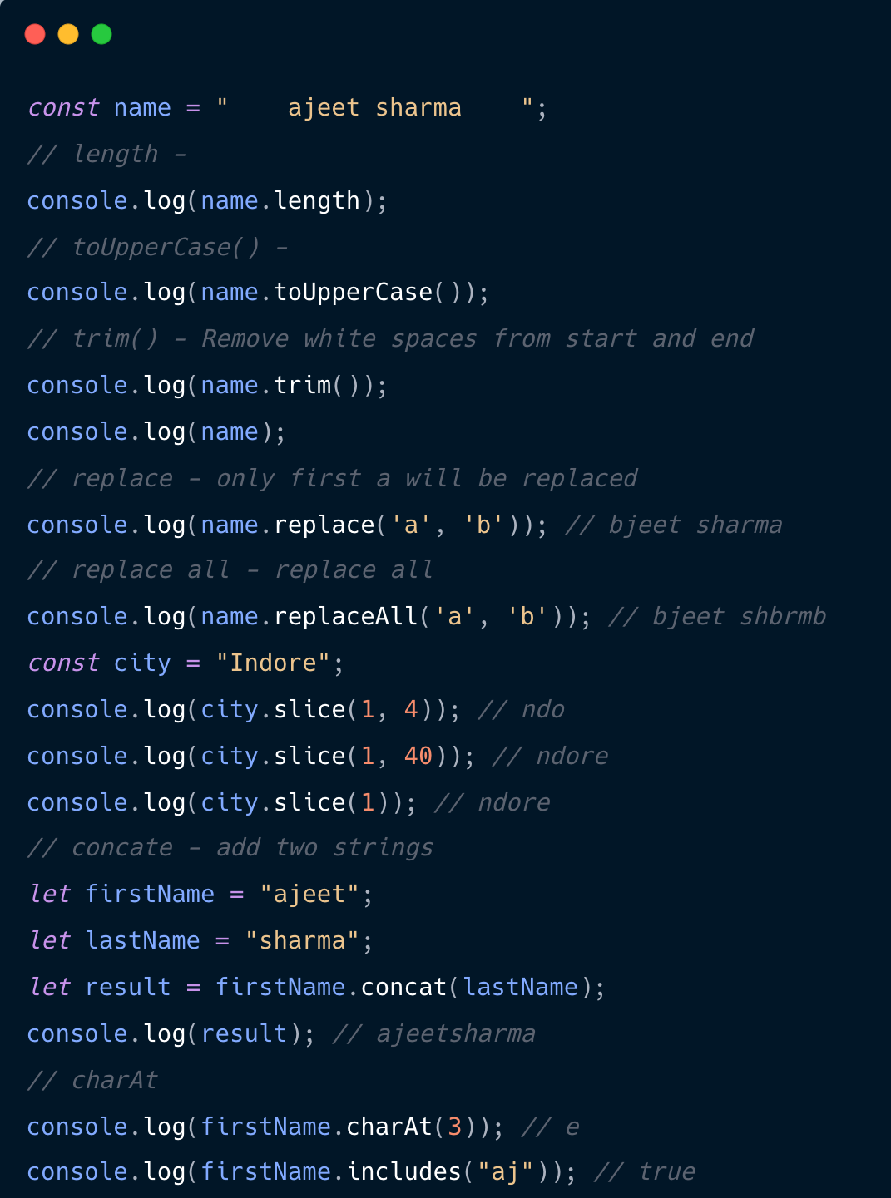

In JavaScript, we can change a value at a particular index in an array, but we cannot directly change a character at a particular index in a string because strings are immutable.

Array methods --
slice()

vs

splice()

in JavaScript
The easiest way to remember:
slice() → copies/extracts part of an array without changing the original.
splice() → adds/removes/replaces items and changes the original array.

forEach:
forEach() in JavaScript
forEach() is an array method used to execute a function once for each element in an array.
Callback: A callback function is a function that you pass as an argument to another function, so the other function can call it later.

Higher-Order Function in JavaScript
A Higher-Order Function (HOF) is a function that does at least one of these:
- Takes another function as an argument, or
- Returns a function.

DOM:
What is DOM in JavaScript?
DOM = Document Object Model
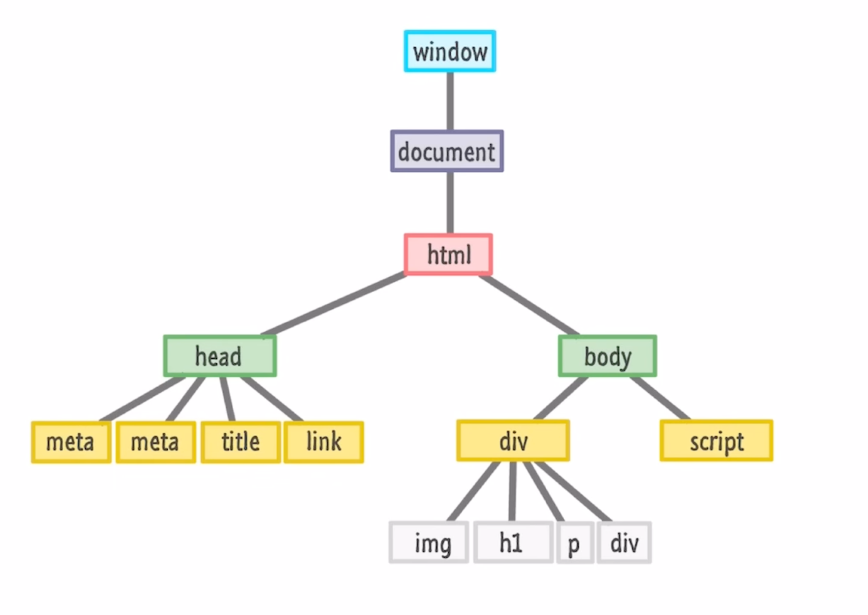The DOM is a tree-like representation of an HTML page that JavaScript can use to read, change, add, or remove HTML elements and their styles/content.
DOM is mainly for web development (HTML + JavaScript).
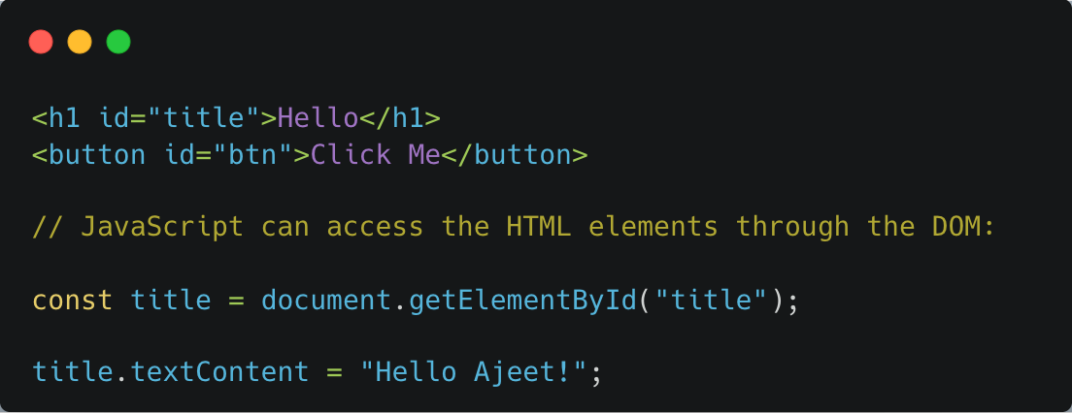
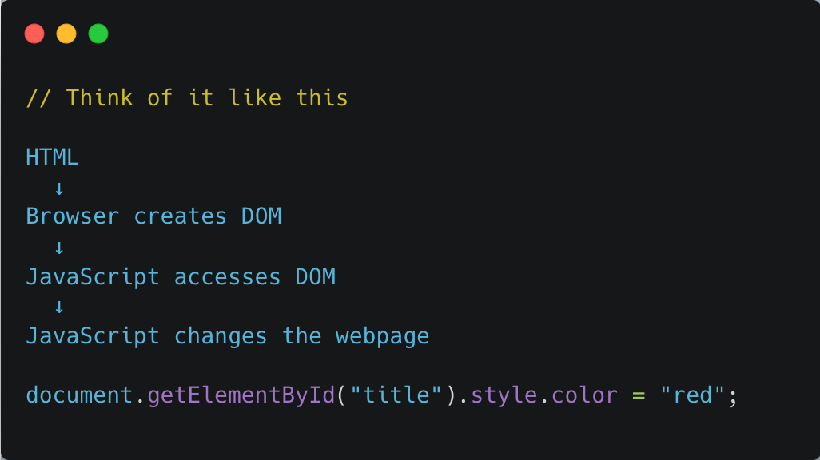
Window object:
The window object represents the browser window. It is the top-level object provided by the browser for a web page.
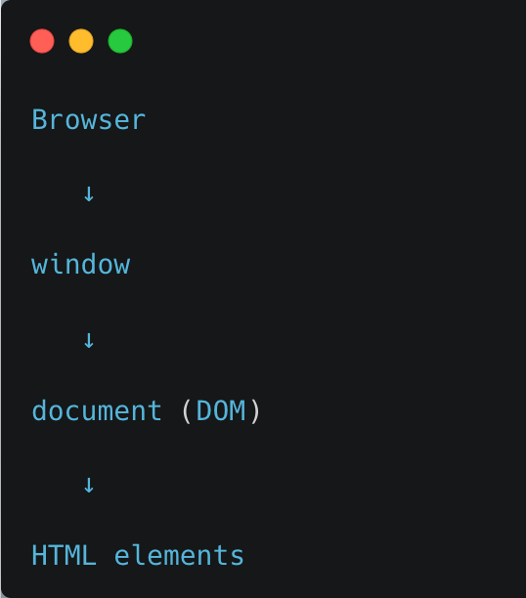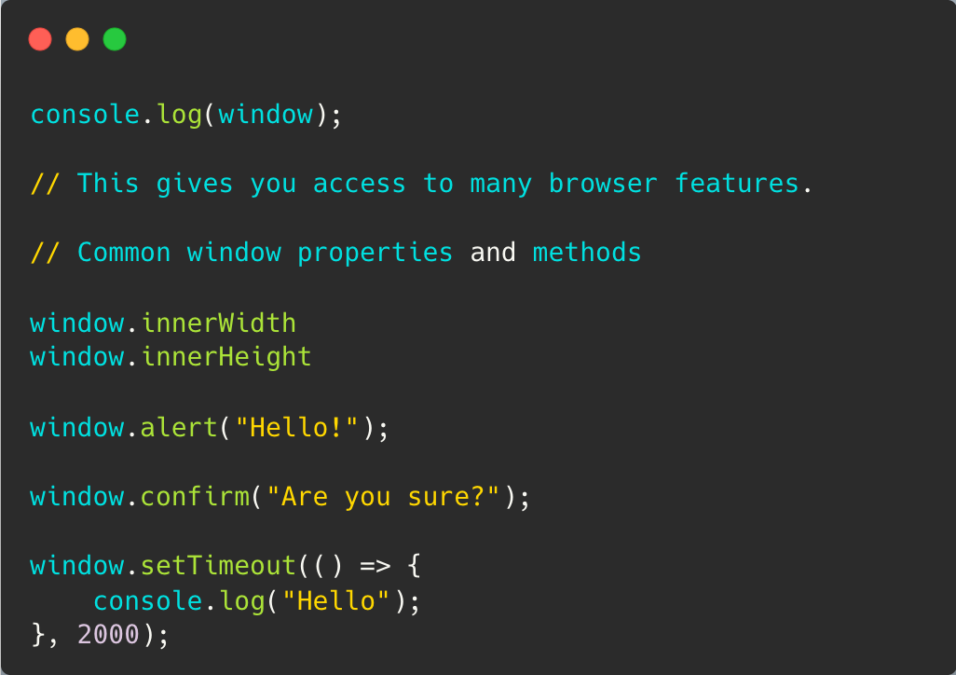

console.log()

vs

console.dir()

in JavaScript
Both are used to inspect/print values in the console, but they are useful for slightly different purposes.

1.

console.log()
Used for general output.

2.

console.dir()
console.dir() is particularly useful for seeing an object’s properties and structure.
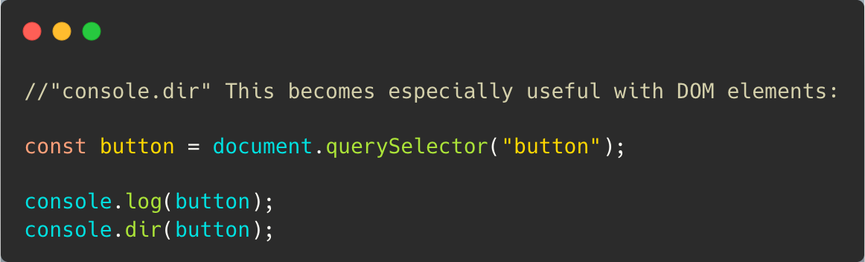

DOM Manipulations:
ID → getElementById()
Class → getElementsByClassName()
Tag → getElementsByTagName()
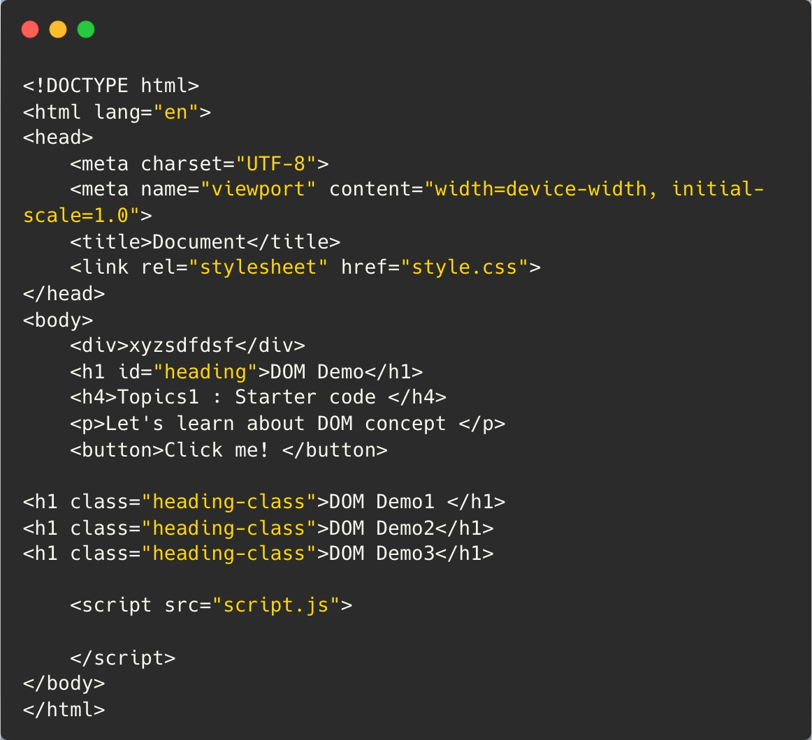
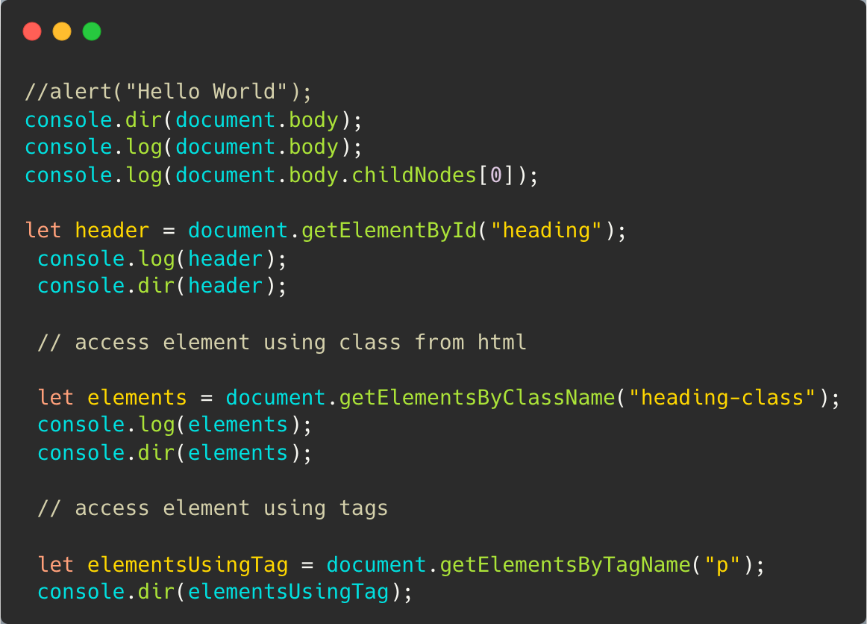

DOM Manipulation Properties in JavaScript
After selecting an HTML element, you can use DOM properties to read or change its content, style, attributes, and more.

- tagName → Returns the name of the HTML tag, such as DIV, P, H1, or BUTTON.
- innerText → Gets or changes the visible text inside an element.
- innerHTML → Gets or changes the HTML content inside an element, including tags.
- textContent → Gets or changes all text content inside an element, including text that may be hidden by CSS.
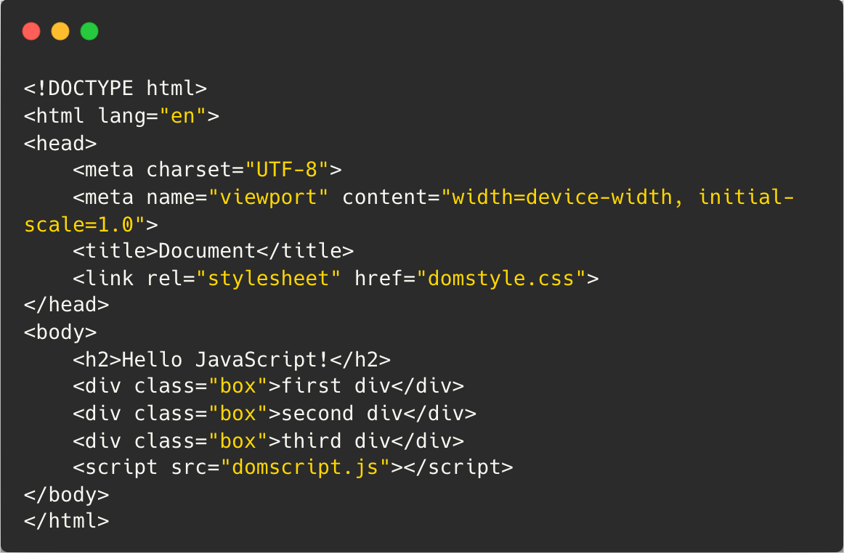

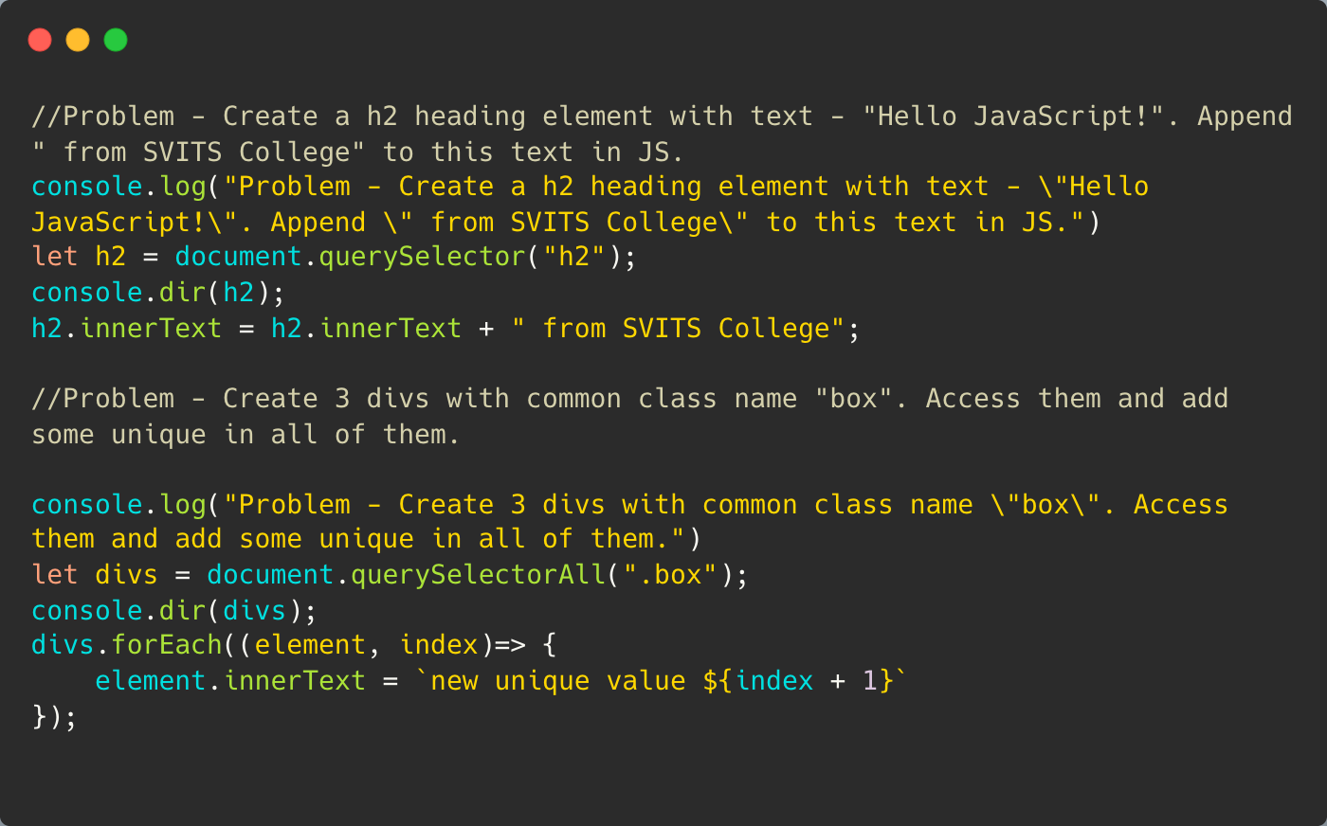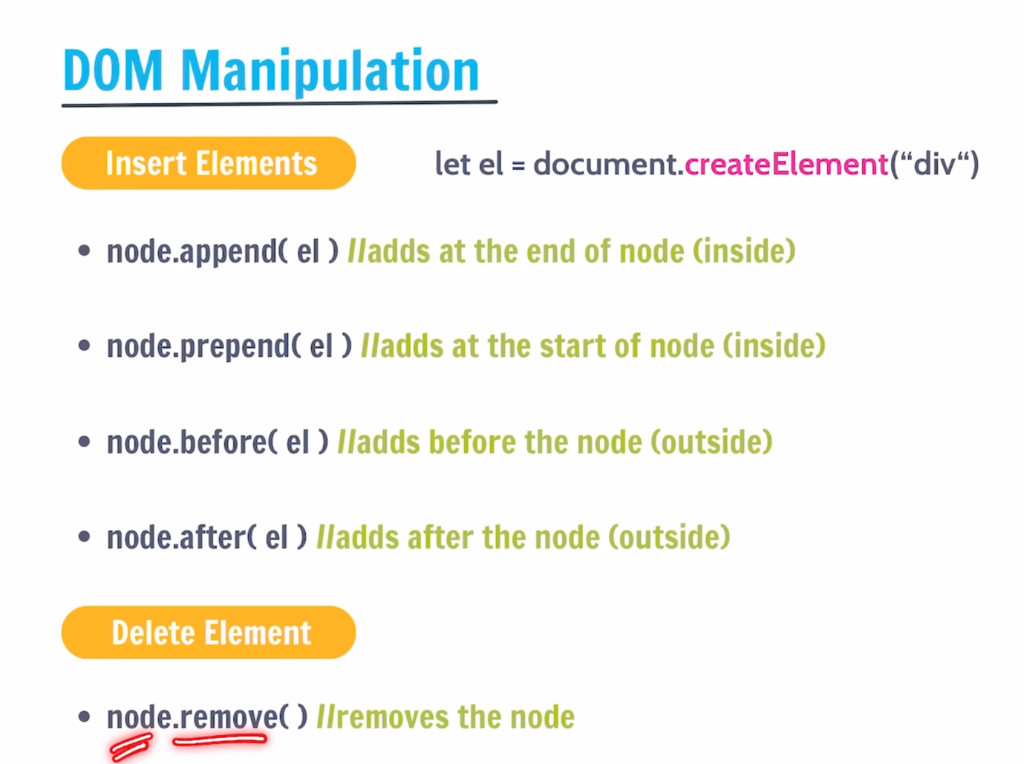

Events:
In JavaScript, events are actions that happen in the browser—such as a user clicking a button, typing on the keyboard, submitting a form, or the page finishing loading. JavaScript can “listen” for these events and run code when they occur.

Common JavaScript events
Event | Happens when
click | User clicks an element
dblclick | User double-clicks
mouseover | Mouse enters an element
mouseout | Mouse leaves an element
keydown | A keyboard key is pressed
keyup | A keyboard key is released
input | Input value changes
change | Form value is changed/committed
submit | A form is submitted
focus | An input receives focus
blur | An input loses focus
DOMContentLoaded | HTML has been loaded and parsed

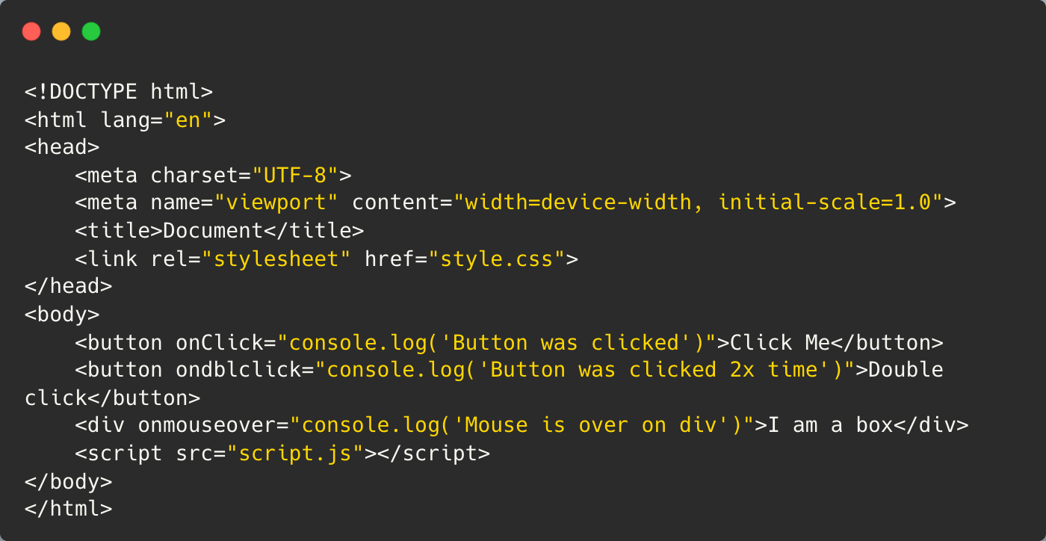

Event Handling in Java script:
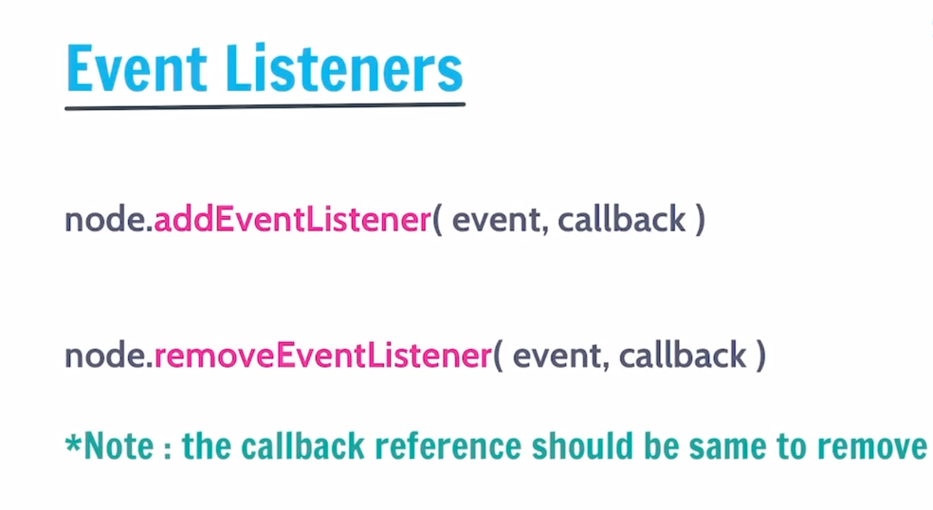
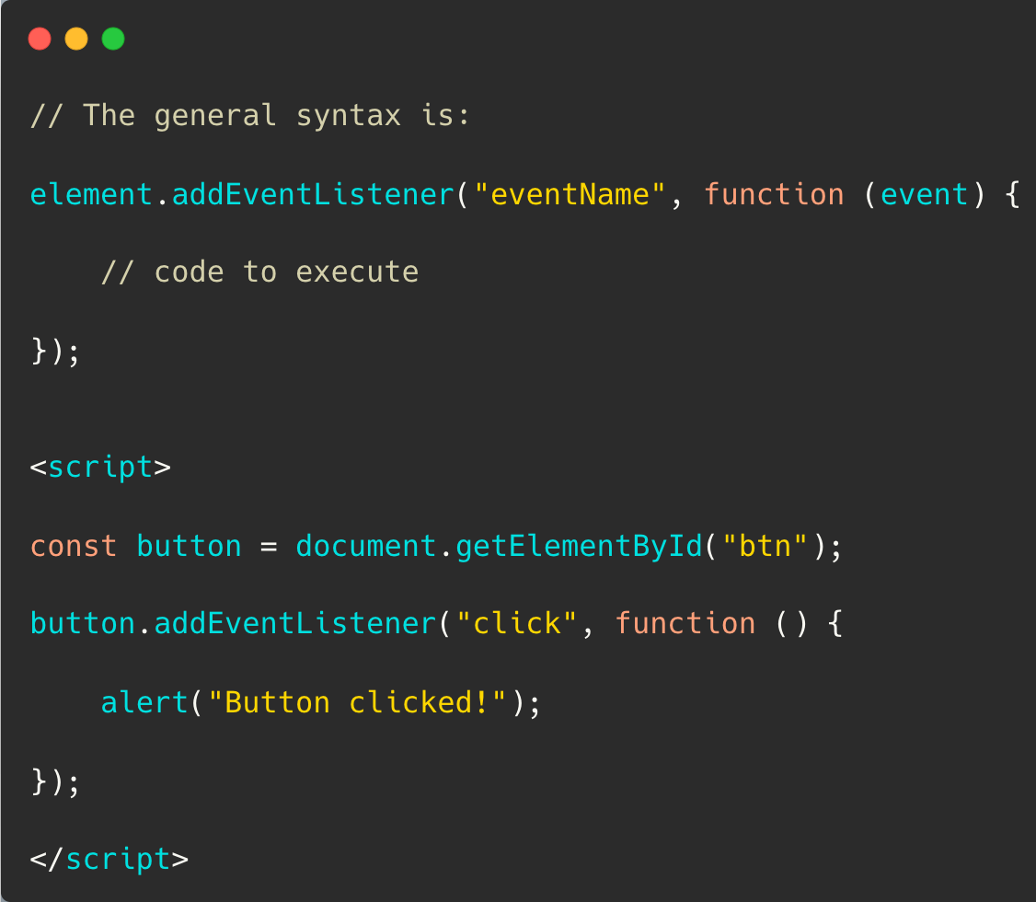
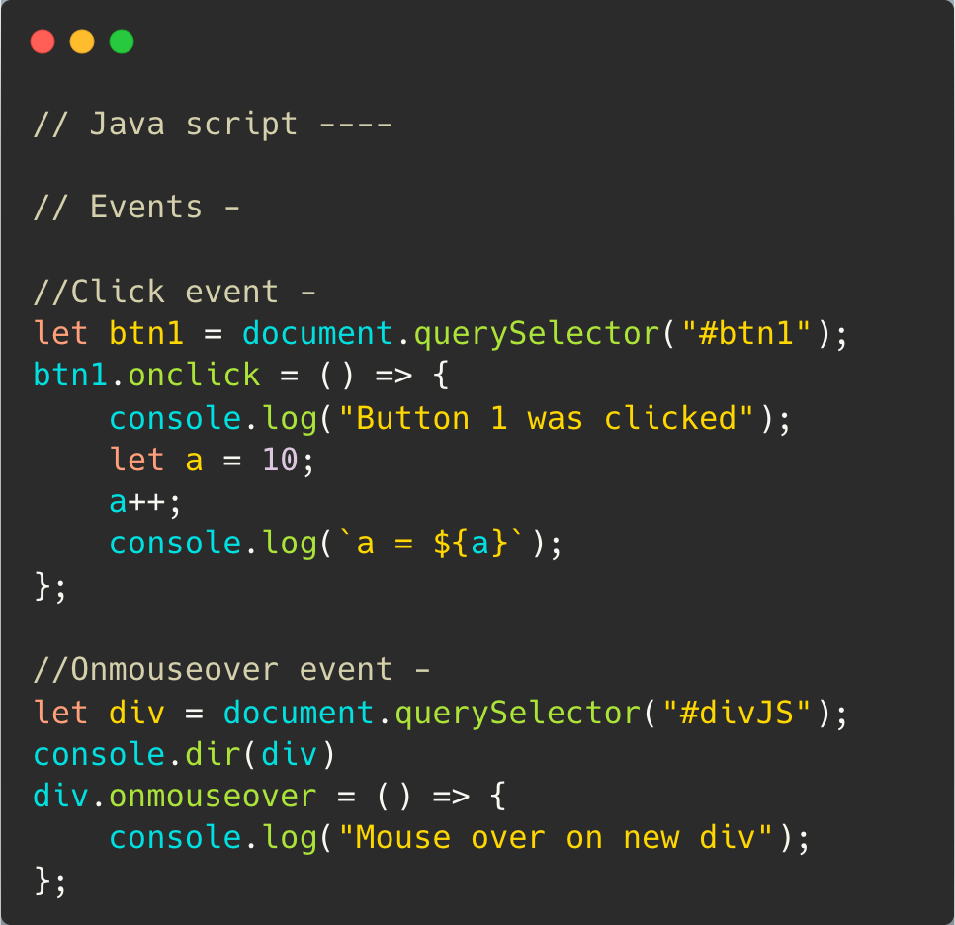

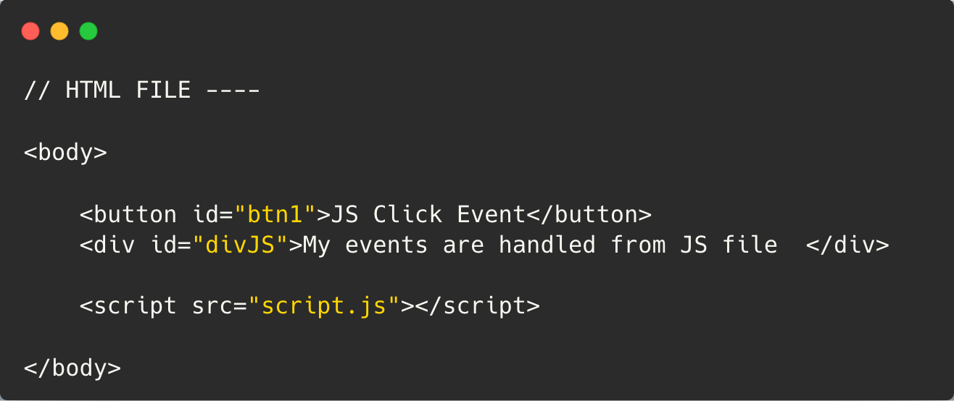

JavaScript Event Object
The Event Object is an object automatically created by the browser when an event happens. It contains information about that event.

For getting random number use Math class in Javascripts:

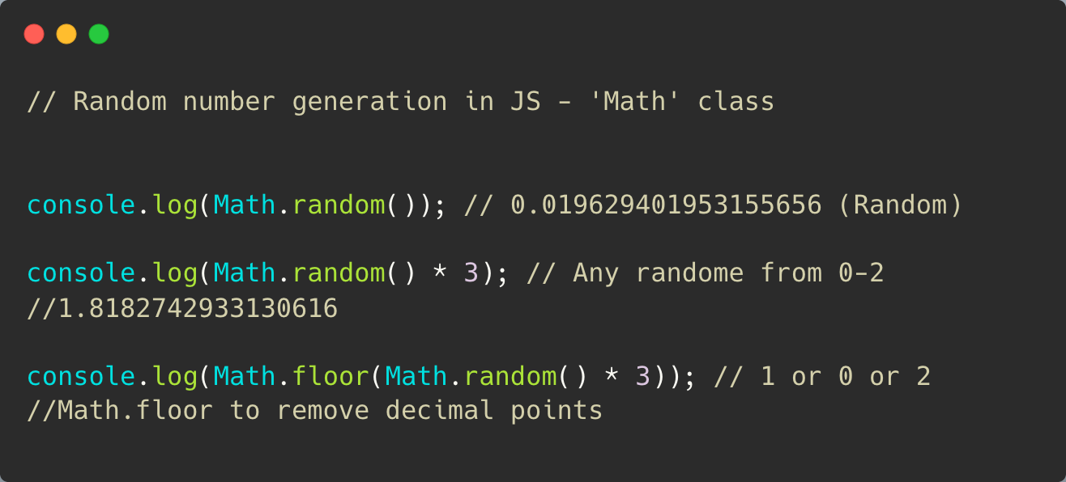
Classes and object in JS:
A Java script object is an entity having state and behavior (properties and method).
In JavaScript, an object is a collection of related data stored as key–value pairs.
Prototype property
The prototype property belongs mainly to constructor functions/classes, not to normal objects.
prototype is a reference type of an object.

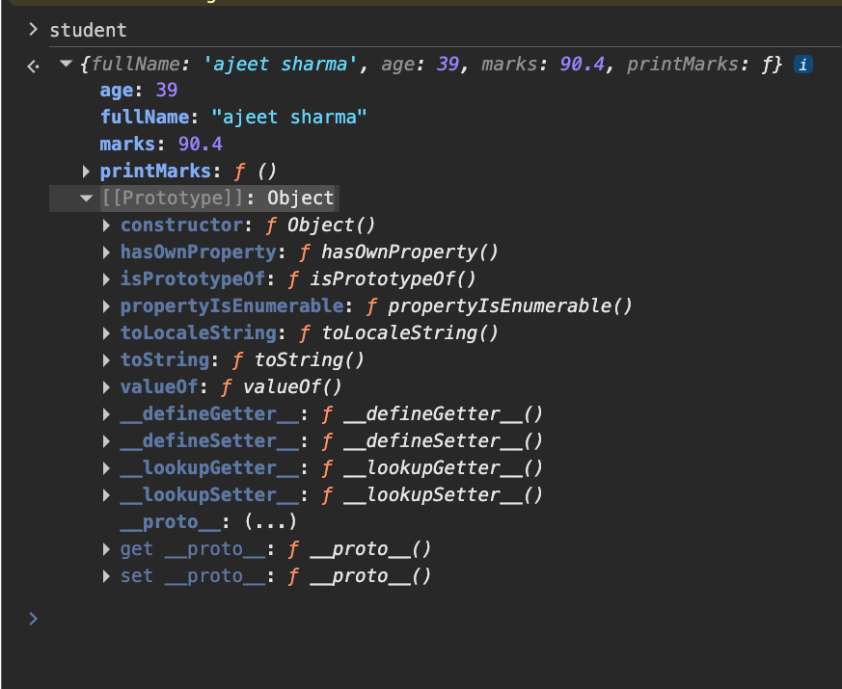

Class in JavaScript
A class in JavaScript is a blueprint for creating objects with properties and methods.
If you come from Swift/iOS, you can think of a JS class as being similar to a Swift class.
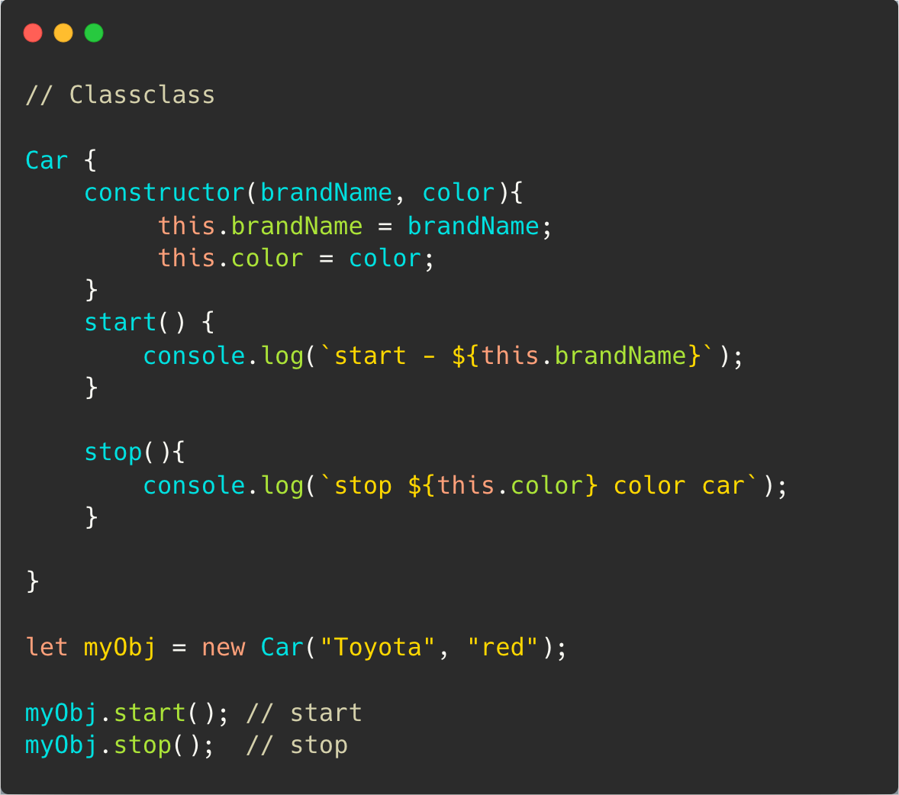
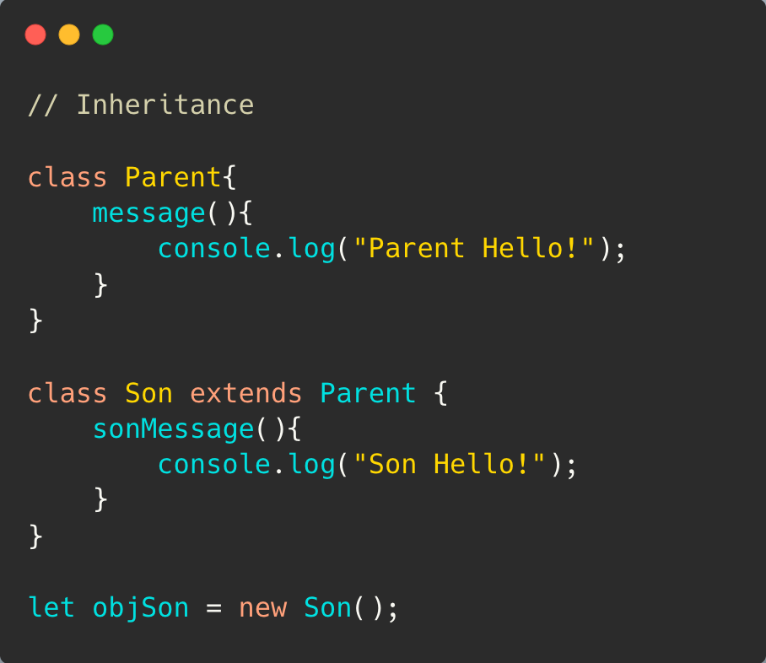
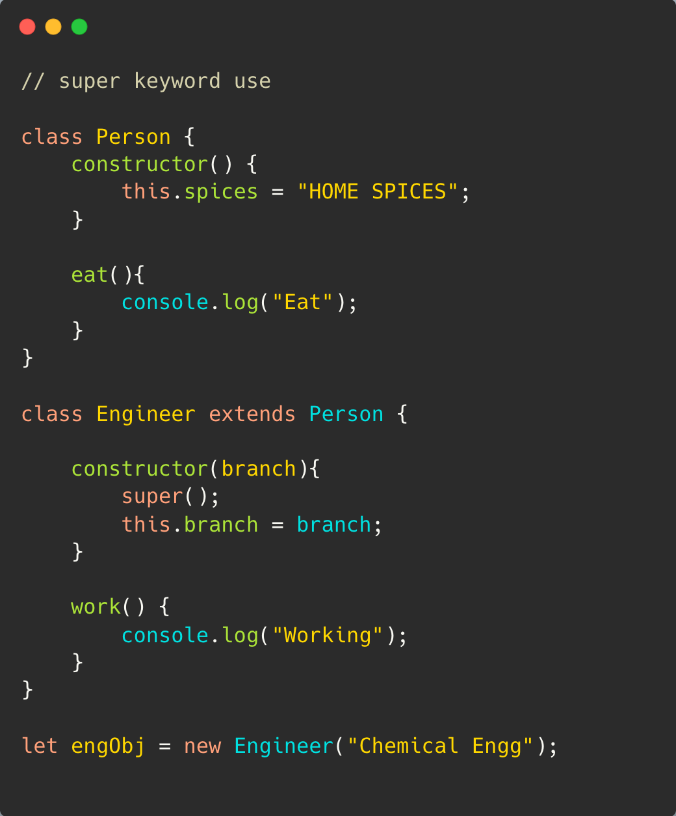
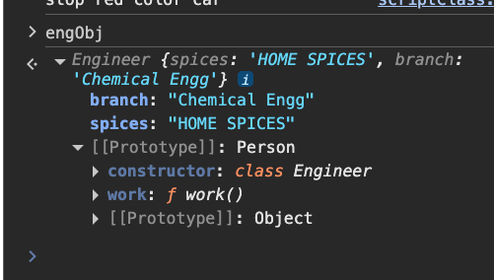
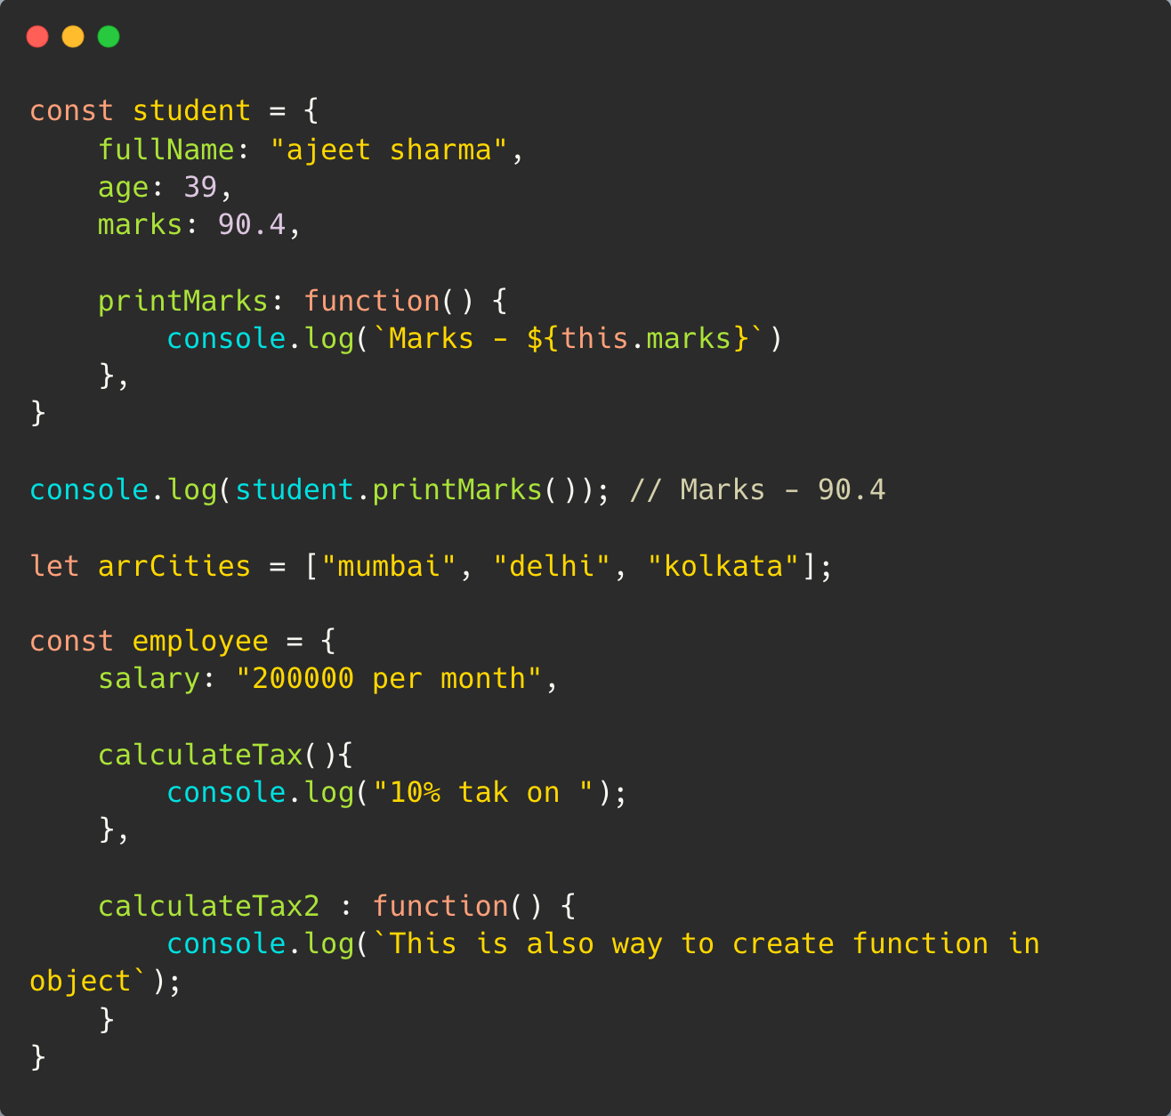

We can set prototype using ‘_ _proto_ :
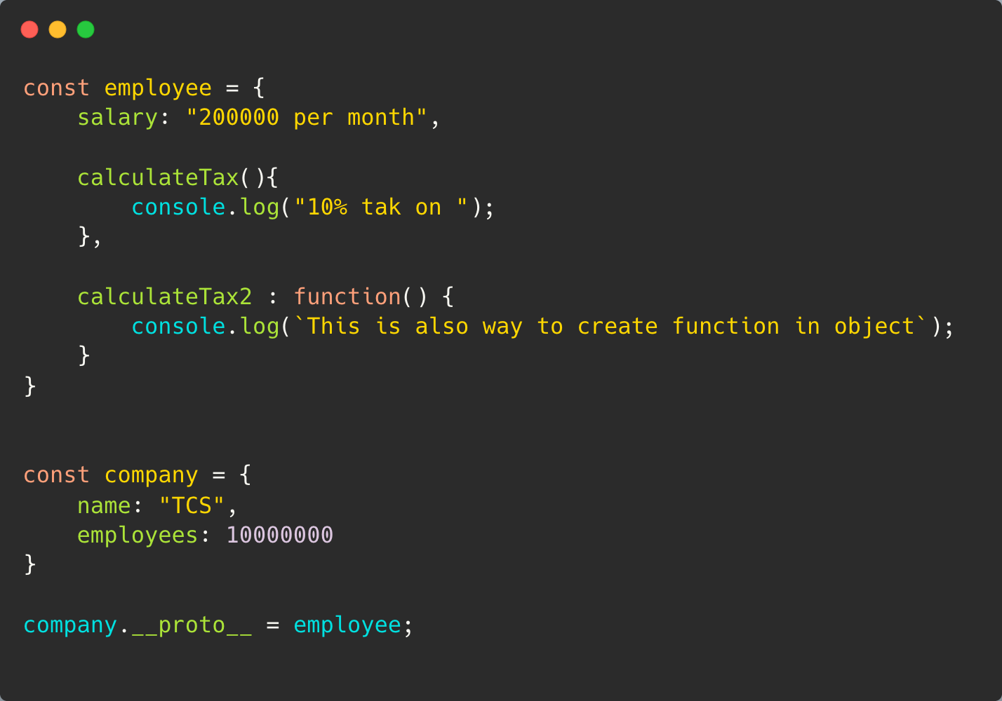

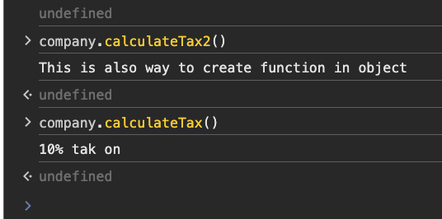_’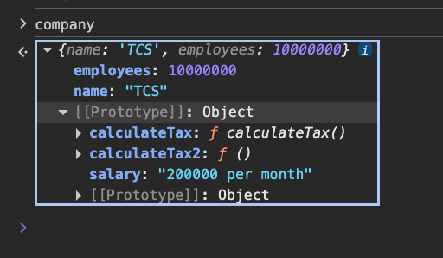

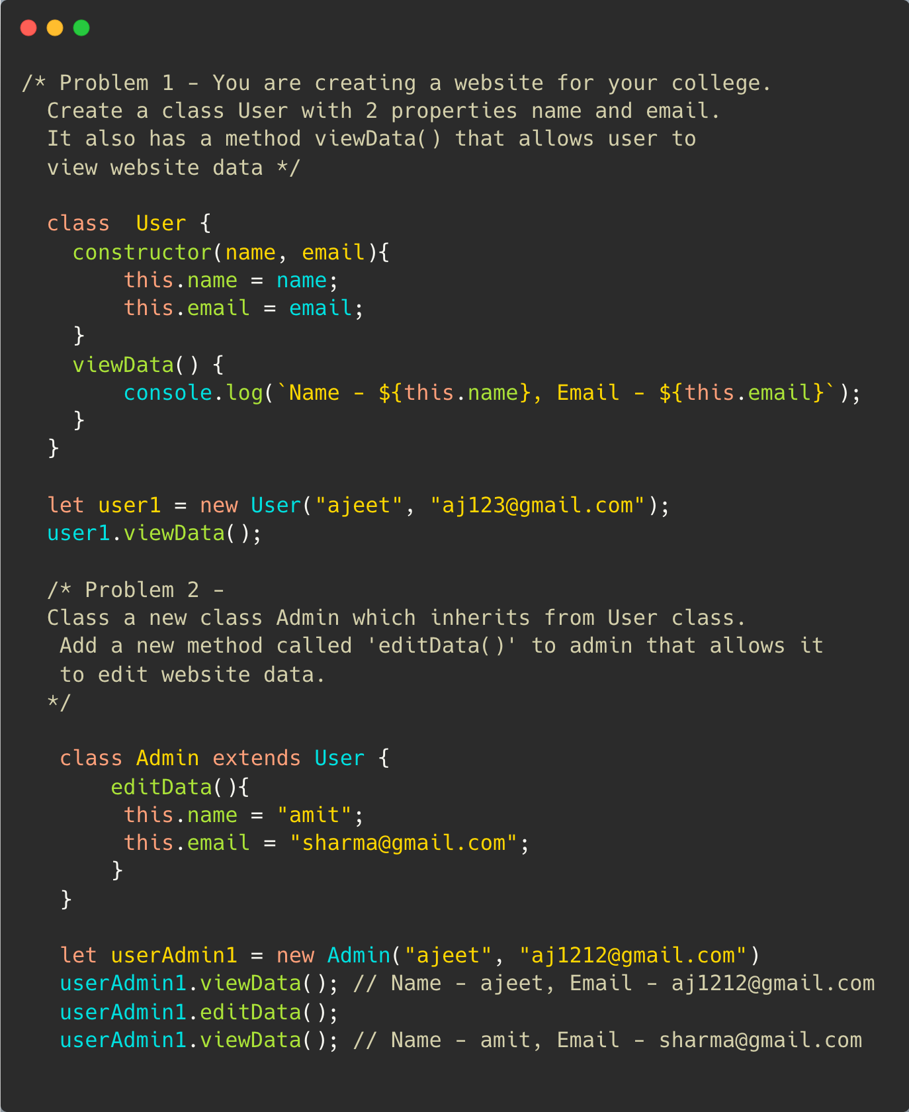
Synchronous and Asynchronous:
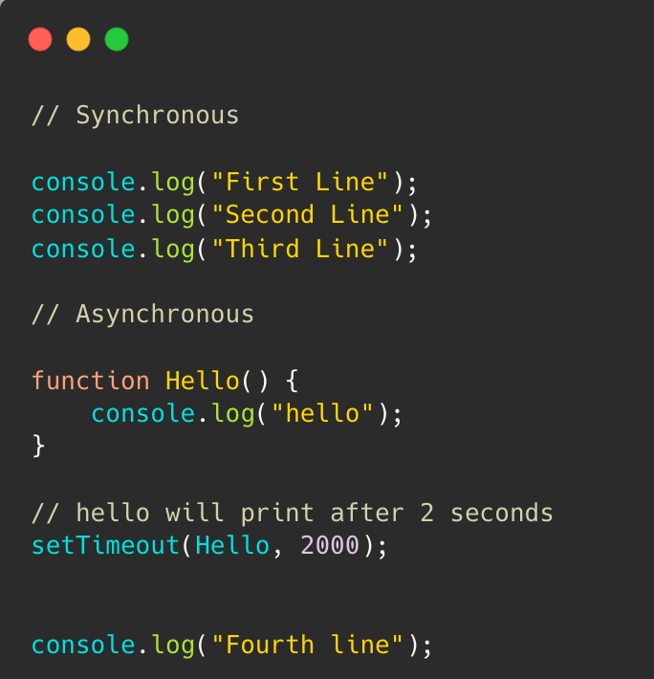
Callback:
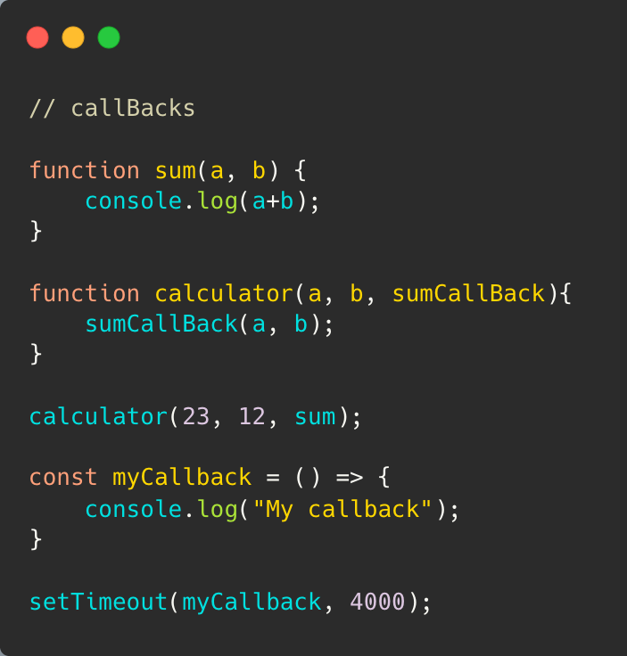

Callback Hell in JavaScript - (Pyramid of Doom )
Callback Hell happens when we have multiple asynchronous operations nested inside callbacks, making the code difficult to read, maintain, and debug.

Simple example
Suppose you need to do these steps one after another:
- Login user
- Get user profile
- Get user’s orders
- Get order details
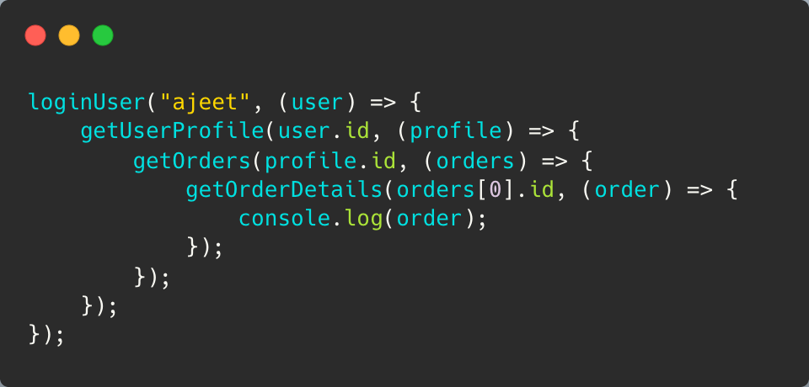

Why is Callback Hell a problem?
- ❌ Difficult to read
- ❌ Difficult to debug
- ❌ Difficult to maintain
- ❌ Error handling becomes complicated
- ❌ Adding another asynchronous step makes nesting deeper

How to avoid Callback Hell?
1. Use Promises

Promise in JavaScript
A Promise is a JavaScript object used to handle the result of an asynchronous operation.
Think of it as:
“I don’t have the result right now, but I promise I’ll give you the result later.”
For example, API calls, database operations, file operations, timers, etc.

1. Promise has 3 states

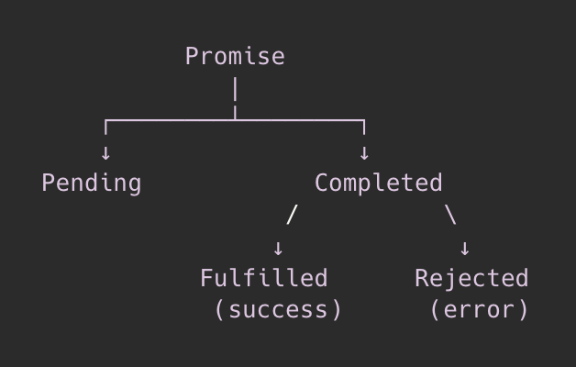
- Pending → operation is still running
- Fulfilled → operation succeeded
- Rejected → operation failed

2. Creating a Promise
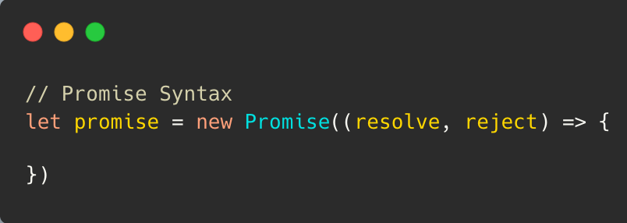
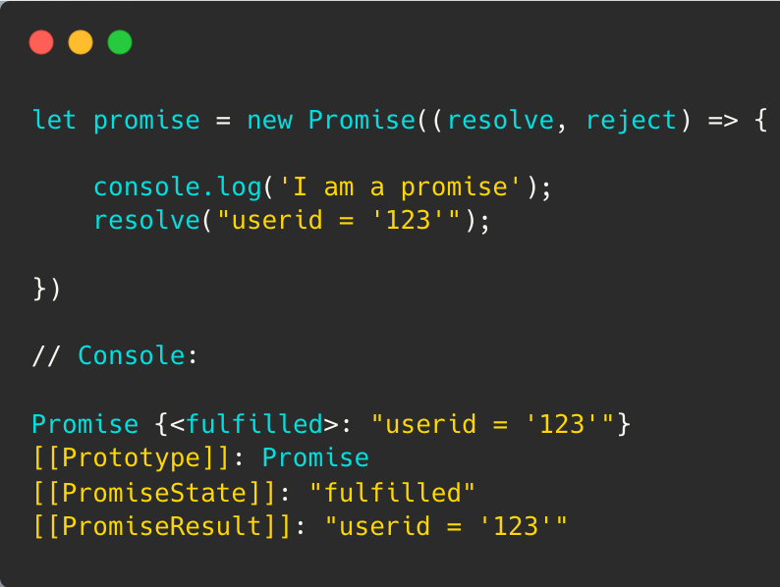

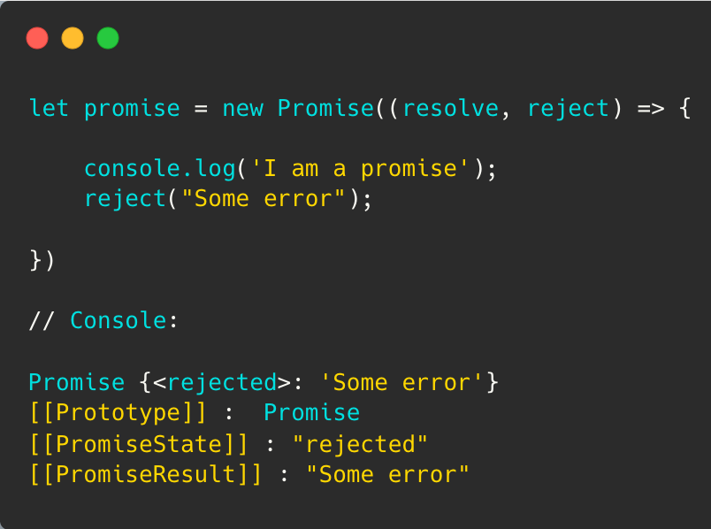
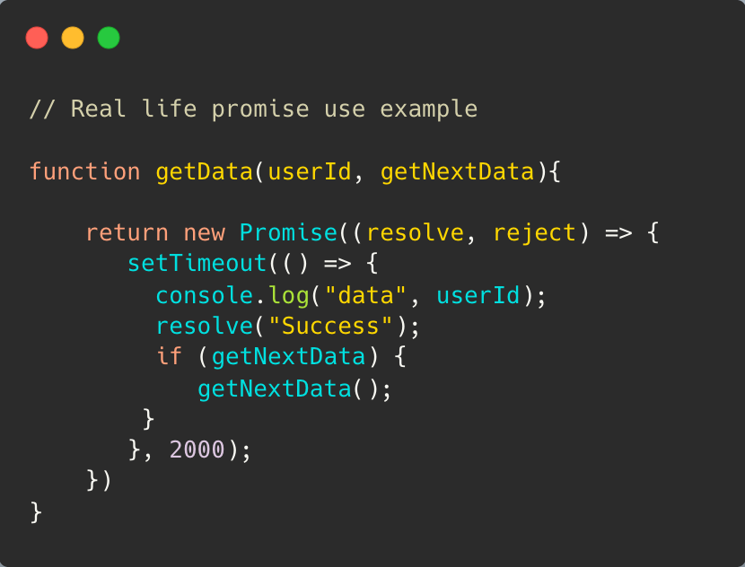

3. Consuming a Promise
We use .then() for success and .catch() for errors.
